Recruitment task

Aleksander Wolny

Excercies.1

The goal of this task was to find as many visual bugs as possible. Without any documentation.

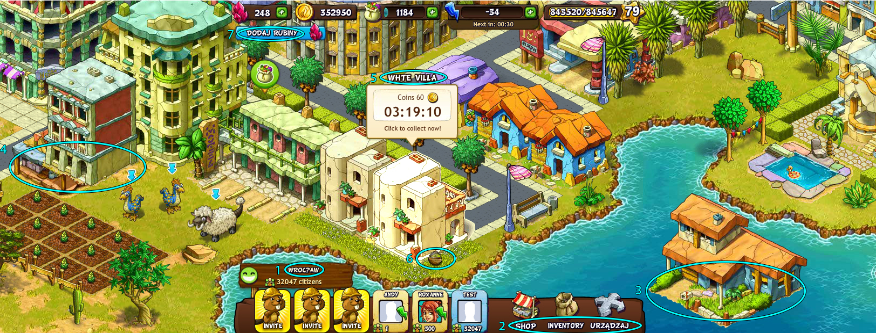

(Larger picture in a separate file.)

1. The font of the city did not load Polish characters.
2. Inscriptions „SHOP, INVENTORY, URZĄDZAJ” should be in the same language.   
   (I assume that all supposed to be in English).
3. The house is in the middle of the water. The player should not be able to build this way.
4. The building on the left in the center of the screen. Something does not fit in this building. It looks like it should not be there, it stands on another and covers it.
5. I do not have data off the names of buildings. It is probably a typo and it should be "WHITE VILLA".
6. The cart does not match the rest of the game style.
7. The inscription " DODAJ RUBINY " is in Polish. If the game is to be in English, this is a mistake.

Excercies.2

Create a test scenario (several test cases) for the window inviting friends in a social game:

A few basic assumptions:

* the window appears immediately after the game is turned on, with all players on the list selected by default
* sending an invitation to a specific person removes it from the list until the invitation is accepted or (if the invitation is not accepted) for 24 hours
* the invitation is sent in the form of a notification on Facebook

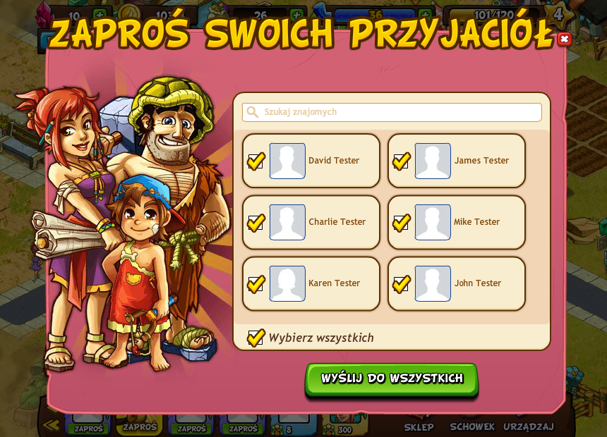

|  |  |  |  |  |
| --- | --- | --- | --- | --- |
| **ID** | **Description** | **Test actions** | **Expected result** | **Comment / Current results** |
| 1 | Checking if the window appears every time | Turning the game on and off | The window appears every time the game is restarted |  |
| 2 | All people marked | Check if all players on the list are selected | All people are marked |  |
| 3 | Deselecting people and the "wybierz wszystkich" button | 1. Checking in turn whether each person can be deselected and marked again. 2. Deselecting all people. 3. Clicking the "Wybierz wszystko" button. | Each person can be individually selected or deselected. The "wybierz wszystko" button selects all unselected people. |  |
| 4 | The "x" button that disables the window | Clicking on the red "x" button in the upper right corner. | The button disables the window with invitations correctly. |  |
| 5 | Finding friends | 1. Clicking on the field "Szukaj znajomych". 2. Entering the person you are looking for. | After clicking on the "szukaj znajomych" area, the phone keypad appears so that you can enter the name of a specific person. |  |
| 6 | Adding people to the list. | 1. Step 5.  2. Adding a specific person to the list. | After selecting a given person, he appears on the list. |  |
| 7 | Send an invitation to a specific person | 1. Deselecting everyone.  2. Select a specific person from the list.  3. Clicking the "Wyślij do wszystkich" button. | The person was removed from the list and got an invitation to play. | Send button to everyone with only one person selected should change the name.  Or the button should simply be named "Wyślij zaproszenie" |
| 8 | Button "Wyślij do wszystkich" | 1. All people are selected.  2. Pressing the button | All selected people have been invited. | I understand that sending to everyone does not remove them from the list. Only individual people? |
| 9 | Notification on facebook | Sending an invitation. | The person got an invitation on facebook. |  |
| 10 | Game installation by notification | 1. Step 9.  2. Clicking on the invitation.  3. Install game. | The received link from the invitation works and allows you to install the game. |  |
| 11 | The person (or persons) did not accept the invitation after 24 hours | Checking your friends list 24 hours after sending an invitation to them. | People have returned to the list, you can send them an invitation again. |  |